PACKSTACK INSTALLATION

1. First, we need a CentOs machine. Login to that machine.
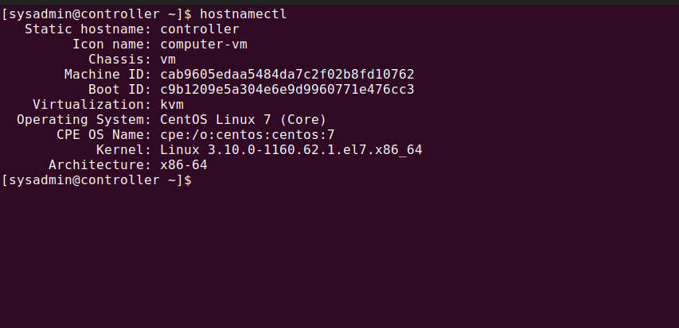

2. Then check whether the SeLinux status is enabled or disabled using the command sestatus.
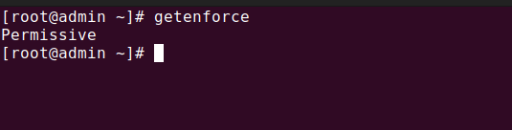
3. If its enabled, then edit the config file by the command vi /etc/selinux/config. Then change the SELINUX value to disabled.
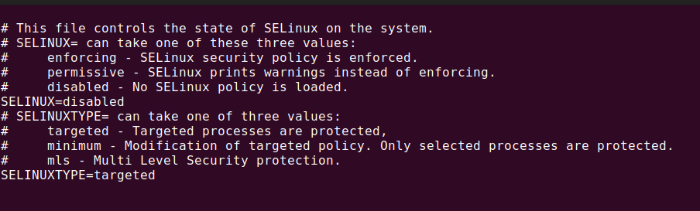
4. Then restart the machine to update the config file.

5. Now update the machine and install the openstack repositories and Packstack packages using the commands below:

$ sudo yum update -y
$ sudo yum install -y centos-release-openstack-train
$ sudo yum update -y
$ sudo yum install -y openstack-packstack
$ sudo packstack –allinone

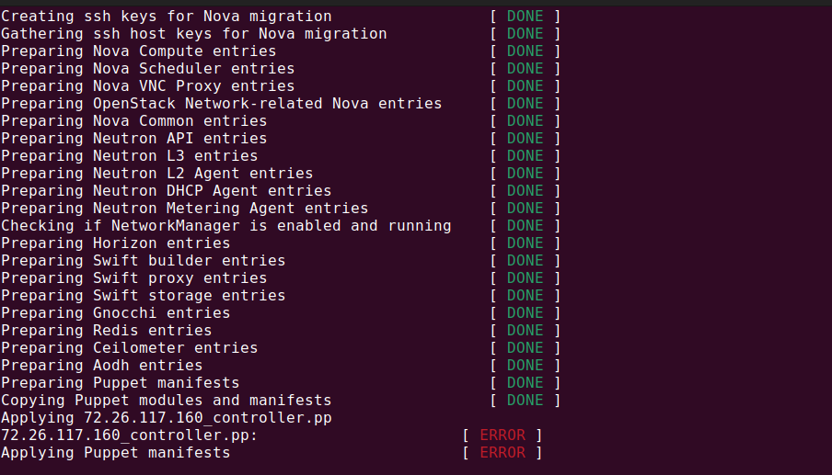
6. After the complete installation, you will find a link in the terminal to the dashboard similar to http://172.xx.x.xx/dashboard . Open the link in a browser and we will see a login portal.

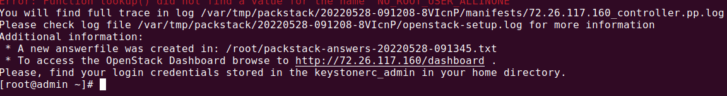
7. The credentials for the login will be kept in the keystonerc_admin file. Display the file contents by executing sudo cat /root/keystonerc_admin.
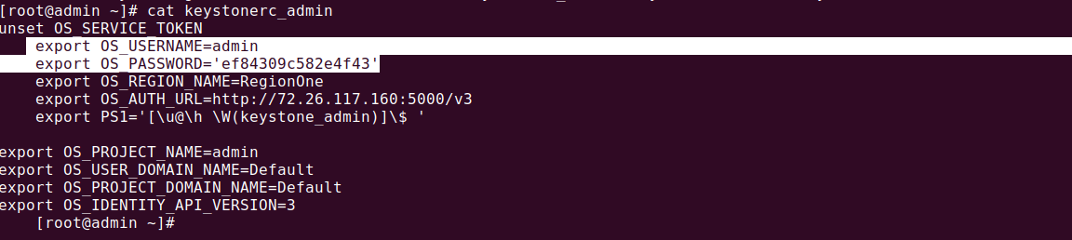

8. Copy the username and password from the file and login to the dashboard.
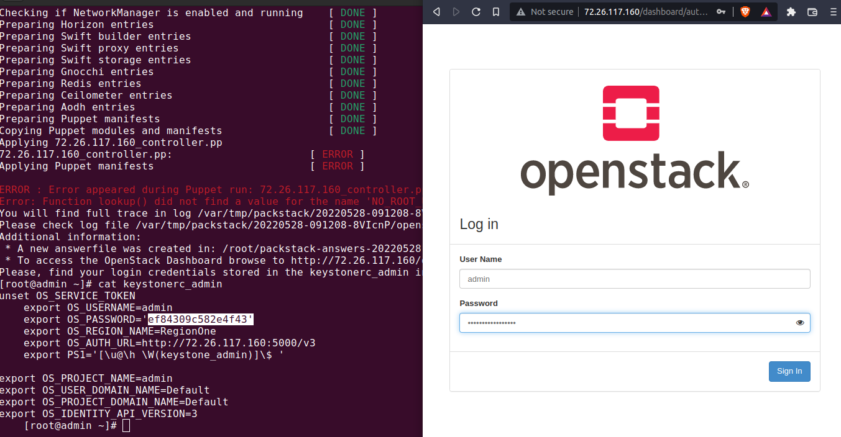
9. The login will lead to the dashboard where you can test the machine by deploying an instance.

